ARKANSAS GENERAL ASSEMBLY
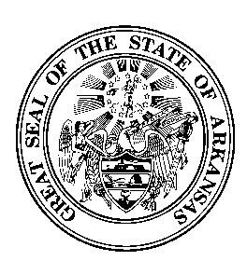

Senator Larry Teague Representative Lane Jean
Senate Co-Chairman House Co-Chairman

Senator Missy Irvin Rep. Douglas House
Senate Vice-Chair House Vice-Chair

JOINT BUDGET COMMITTEE

PRE-FISCAL SESSION BUDGET HEARINGS PARAMETERS
March 8, 2016

- The Committee hearings will be held in Committee Room A of the Multi-Agency Complex (Big Mac).

- During the first week of budget hearings beginning Tuesday, March 8, 2016 at 9:00 a.m., the Joint Budget Committee will meet Tuesday through Thursday. After the first week of budget hearings the Committee will meet as needed upon call of the Co-Chairs.

- A member of the legislative fiscal staff will summarize the agency budget request and executive recommendation before the agency begins its presentation.

- The Director of the Department of Higher Education will appear and present the Arkansas Higher Education Coordinating Board (AHECB) recommendations for all institutions of higher education. The directors of the remaining five agencies that make up what is commonly referred to as the "Big Six" will appear and present his/her budget request before the Committee.

- Budget subcommittees may be appointed to consider selected budgetary matters in more depth.

- Each member will receive a Budget Manual, Tax Handbook, "A" Book (Agency Expenditures for 10 years) and "B" Book (Selected Statistical Data).

- Member’s seats are permanently assigned and name plates will be used.

- Press and Public are not allowed around the members’ seating area.

